Lab No 6

Muhammad Saad Qadeer

Reg # 849

Web Engineering

IDE Used:

Php Storm 8.0

Steps to install larval and deploy a sample application:

1. Click on File & Select New Project
2. A window will be popped up type the name of the project and in type select composer project
3. Click Ok
4. A new Compose Project window will be opened in filter packages type laravel/laravel in version to install select the latest version and in Path to Php Executable select the php.exe file in xampp or wampp
5. Click Ok and you are good to go.
6. If you receive a bad gateway error configure the php interpreter.

Below are the Snap Shots

Here is the step 1:

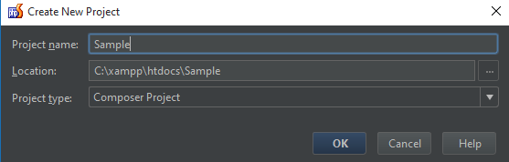

Here is the step 2:

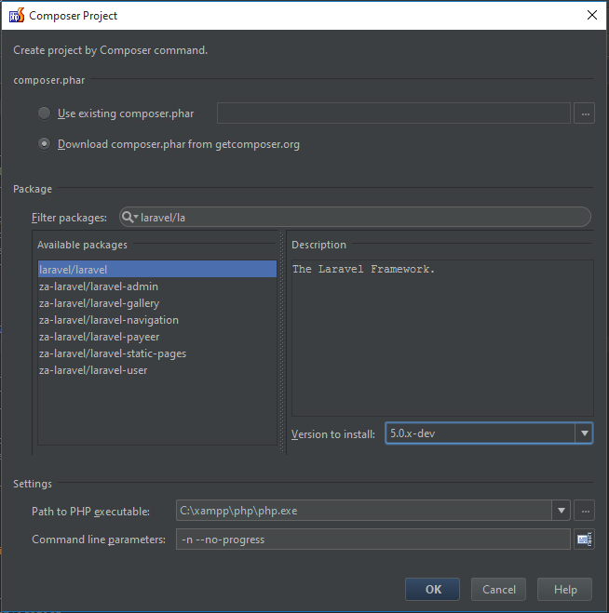

Click Ok and The Php Storm will take care of the rest you might have to wait after this step because php storm downloads the files on its own from internet.